** The information contained in this document is for Educational Purposes ONLY **
Financial Health Analysis for Mr.XXXXX
Current Age: 55 yrs Retirement Age: 60 yrs Survival Age: 90 yrs

Financial Details
Current Corpus: Rs. 7,50,00,000 Monthly Saving/Investment: Rs. 1,000
Investment Rate of Return: 12.00% Expected Rate of Return After Retirement: 8.00%
Expected Capital Gains Tax on withdrawal: 12.50%

Investment By Age (Current Corpus and Monthly Investment)

Age | Investment by Age
55 | Rs. 7,50,12,000
56 | Rs. 12,000
57 | Rs. 12,000
58 | Rs. 12,000
59 | Rs. 12,000

Investment Performance (Incl. Tax Adjusted Withdrawals)

Age | Corpus Value by Year | Age | Corpus Value by Year | Age | Corpus Value by Year
56 | Rs. 8,39,56,516 | 68 | Rs. 15,14,56,281 | 80 | Rs. 10,47,04,485
57 | Rs. 9,40,44,065 | 69 | Rs. 15,24,99,146 | 81 | Rs. 9,14,21,025
58 | Rs. 10,53,42,119 | 70 | Rs. 15,29,88,706 | 82 | Rs. 7,58,29,449
59 | Rs. 11,68,70,940 | 71 | Rs. 15,28,44,085 | 83 | Rs. 5,76,73,495
60 | Rs. 13,09,08,219 | 72 | Rs. 15,19,75,830 | 84 | Rs. 3,66,72,281
61 | Rs. 13,43,00,648 | 73 | Rs. 15,02,85,107 | 85 | Rs. 1,25,18,102
62 | Rs. 13,75,57,358 | 74 | Rs. 14,76,62,821 | 86 | Insufficient
63 | Rs. 14,06,44,083 | 75 | Rs. 14,39,88,659 | 87 | Insufficient
64 | Rs. 14,35,22,468 | 76 | Rs. 13,91,30,051 | 88 | Insufficient
65 | Rs. 14,61,49,668 | 77 | Rs. 13,29,41,036 | 89 | Insufficient
66 | Rs. 14,84,77,906 | 78 | Rs. 12,52,61,034 | 90 | Insufficient
67 | Rs. 15,04,53,987 | 79 | Rs. 11,59,13,503

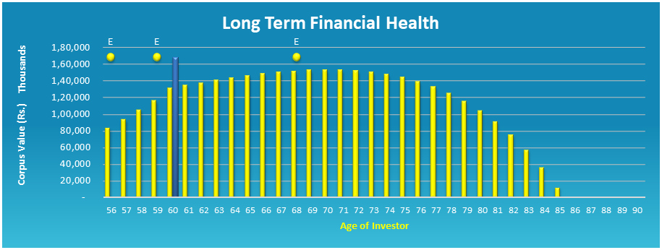

Financial Events
Age | Type | Amount | Description
56 | Expense | Rs. 50,000
59 | Expense | Rs. 10,00,000
68 | Expense | Rs. 5,00,000

Expenses Per Year (Inflation Adjusted)
Current Expenses: Rs. 2,50,000 Inflation Rate used: 5.75%
Expenses after retirement are expected to be same as current monthly expenses
Age | Expense per Month | Age | Expense per Month | Age | Expense per Month
56 | Rs. 2,64,375 | 68 | Rs. 5,17,112 | 80 | Rs. 10,11,462
57 | Rs. 2,79,577 | 69 | Rs. 5,46,846 | 81 | Rs. 10,69,621
58 | Rs. 2,95,652 | 70 | Rs. 5,78,290 | 82 | Rs. 11,31,124
59 | Rs. 3,12,652 | 71 | Rs. 6,11,542 | 83 | Rs. 11,96,163
60 | Rs. 3,30,630 | 72 | Rs. 6,46,705 | 84 | Rs. 12,64,943
61 | Rs. 3,49,641 | 73 | Rs. 6,83,891 | 85 | Rs. 13,37,677
62 | Rs. 3,69,745 | 74 | Rs. 7,23,215 | 86 | Rs. 14,14,594
63 | Rs. 3,91,006 | 75 | Rs. 7,64,799 | 87 | Rs. 14,95,933
64 | Rs. 4,13,488 | 76 | Rs. 8,08,775 | 88 | Rs. 15,81,949
65 | Rs. 4,37,264 | 77 | Rs. 8,55,280 | 89 | Rs. 16,72,911
66 | Rs. 4,62,407 | 78 | Rs. 9,04,459 | 90 | Rs. 17,69,103
67 | Rs. 4,88,995 | 79 | Rs. 9,56,465

Lifestyle Expenses Per Year (Inflation Adjusted)
Current Lifestyle Expense: Rs. 15,00,000 Inflation Rate used: 5.75%
Lifestyle Expenses after retirement are expected to be same as current lifestyle expenses
Age | Expense per Year | Age | Expense per Year | Age | Expense per Year
56 | Rs. 15,86,250 | 68 | Rs. 31,02,674 | 80 | Rs. 60,68,770
57 | Rs. 16,77,459 | 69 | Rs. 32,81,078 | 81 | Rs. 64,17,724
58 | Rs. 17,73,913 | 70 | Rs. 34,69,740 | 82 | Rs. 67,86,743
59 | Rs. 18,75,913 | 71 | Rs. 36,69,250 | 83 | Rs. 71,76,981
60 | Rs. 19,83,778 | 72 | Rs. 38,80,232 | 84 | Rs. 75,89,657
61 | Rs. 20,97,846 | 73 | Rs. 41,03,345 | 85 | Rs. 80,26,063
62 | Rs. 22,18,472 | 74 | Rs. 43,39,287 | 86 | Rs. 84,87,561
63 | Rs. 23,46,034 | 75 | Rs. 45,88,796 | 87 | Rs. 89,75,596
64 | Rs. 24,80,931 | 76 | Rs. 48,52,652 | 88 | Rs. 94,91,693
65 | Rs. 26,23,584 | 77 | Rs. 51,31,680 | 89 | Rs. 1,00,37,465
66 | Rs. 27,74,440 | 78 | Rs. 54,26,751 | 90 | Rs. 1,06,14,619
67 | Rs. 29,33,971 | 79 | Rs. 57,38,789

With your current investment and expenses,
you DO NOT have sufficient funds
to last your lifetime.

Your invested funds are expected to last approx.

Thank you for reviewing the customized Long Term Financial Health report. We appreciate your trust in Nivra Fintech and remain committed to providing high-quality, goal-oriented financial solutions. Please contact us should you require any further assistance.

Nivra Fintech Team!
The Financial Engineers

